Compton Scattering
  - Lesson 57 of Quantum, Actually, Volume 2: A QED Course
Lothar J. Musiol

Finishing the calculation Lesson 50 began — the interference term vanishes identically, leaving the remarkably simple result −2e⁴(s/u+u/s)

First edition, 2026

How to use this lesson
Lesson 50 set up Compton scattering in full: the two diagrams, the vertex factors, the propagator, and the momentum-conservation bookkeeping that fixes each diagram's internal momentum to s=(p+k)² and u=(p−k′)² respectively. What Lesson 50 left undone was the spin sum. This lesson finishes it, reusing the trace-reduction method of Lessons 55 and 56 essentially unchanged, and finds again what Lesson 56 found: the interference term between the two diagrams vanishes identically, for the same reason, q_{A}·q_{B}=0. What remains is one of the cleanest formulas in this course. Expect six to eight hours.

Learning objectives
- Recall Compton scattering's two diagrams from Lesson 50 and identify their internal momenta with s=(p+k)² and u=(p−k′)².
- Reduce the direct and crossed squared-amplitude traces to T_{AA}=T_{BB}=−8su using the same method as Lesson 56.
- Show that the interference trace vanishes identically, T_{AB}=0, because q_{A}·q_{B}=0.
- Assemble the complete result (1/4)Σ|ℳ|²=−2e⁴(s/u+u/s).
- Explain why no relative sign is needed between Compton's two diagrams, in contrast with Lesson 55's Møller scattering.
- Reproduce the complete calculation, and the vanishing of the interference term in particular, from memory.

Notation and conventions
Symbol | Meaning
p, k | Incoming electron, photon momenta
p′, k′ | Outgoing electron, photon momenta
s = (p+k)², u = (p−k′)² | Internal electron momenta squared, direct and crossed diagrams
q_{A} = p+k, q_{B} = p−k′ | Internal electron four-momenta
First pass: the result before the derivation
For Compton scattering the interference term cancels, leaving (1/4)Σ|ℳ|² = −2e⁴(s/u + u/s) at high energy (positive, since u < 0). With the electron mass kept, this becomes the Klein–Nishina formula, which reduces to Thomson scattering at low energy.
Light scattering off a free electron, the basic process behind Prologue 5's glass, now computed exactly.

1 Completing Compton scattering
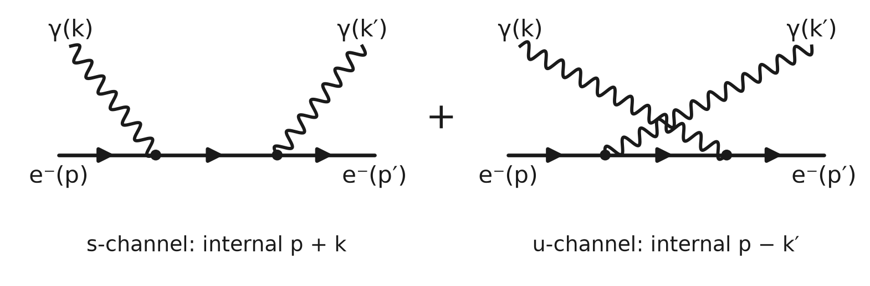
Figure 57.1. Compton scattering: the s-channel (absorb, then emit) and u-channel (emit, then absorb) diagrams.

1.1 Recap
Lesson 50 derived iℳ_{A}=(ie)²ū(p′)γ^{β}[i(q̸_{A}+m)/(q_{A}²−m²+iε)]γ^{α}u(p)ε_{α}(k)ε_{β}(k′), with q_{A}=p+k the direct diagram's internal momentum (q_{A}²=s), and identified a second, crossed diagram with internal momentum q_{B}=p−k′ (q_{B}²=u, Lesson 50, Section 3.1). Both enter with a plain plus sign: the two diagrams differ in which of the two photon fields is contracted with the incoming versus outgoing photon, an ordinary bosonic reassignment carrying no minus sign, as in Lesson 56, Section 1.2.

1.2 The two amplitudes and the three traces
$$i ℳ_{A}={\left(ie\right)}^{2} ū\left(p′\right)γ^{β} \left[\frac{i\left({\overset{/}{q}}_{A}+m\right)}{q_{A}^{2}−m^{2}+iε}\right] γ^{α} u\left(p\right) ε_{α}\left(k\right)ε_{β}\left(k′\right)$$
$$i ℳ_{B}={\left(ie\right)}^{2} ū\left(p′\right)γ^{α} \left[\frac{i\left({\overset{/}{q}}_{B}+m\right)}{q_{B}^{2}−m^{2}+iε}\right] γ^{β} u\left(p\right) ε_{α}\left(k\right)ε_{β}\left(k′\right)$$
Averaging over the initial electron spin and photon polarization (a factor of 1/4, two unmeasured initial degrees of freedom, as in Lesson 56) and using electron completeness on both ends (Σu(p)ū(p)=p̸+m, Σu(p′)ū(p′)=p̸′+m) and the covariant photon polarization sum,
$$T_{AA}=\operatorname{Tr}\left[\left(\overset{/}{p}′+m\right)γ^{β}\left({\overset{/}{q}}_{A}+m\right)γ^{α}\left(\overset{/}{p}+m\right)γ_{α}\left({\overset{/}{q}}_{A}+m\right)γ_{β}\right]$$
$$T_{BB}=\operatorname{Tr}\left[\left(\overset{/}{p}′+m\right)γ^{α}\left({\overset{/}{q}}_{B}+m\right)γ^{β}\left(\overset{/}{p}+m\right)γ_{β}\left({\overset{/}{q}}_{B}+m\right)γ_{α}\right]$$
$$T_{AB}=\operatorname{Tr}\left[\left(\overset{/}{p}′+m\right)γ^{β}\left({\overset{/}{q}}_{A}+m\right)γ^{α}\left(\overset{/}{p}+m\right)γ_{β}\left({\overset{/}{q}}_{B}+m\right)γ_{α}\right]$$
with (1/4)Σ|ℳ|²=(e⁴/4)[T_{AA}/(q_{A}²−m²)²+T_{BB}/(q_{B}²−m²)²+2T_{AB}/((q_{A}²−m²)(q_{B}²−m²))].
Worked example 1
Compare T_{AA}'s index structure with T_{AB}'s and identify the one difference. T_{AA} has α contracted directly around (p̸+m) alone (γ^{α}(p̸+m)γ_{α}, an adjacent pair), and separately β contracted around (q̸_{A}+m) on both sides; T_{AB} instead has α contracted around the longer chain (p̸+m)γ_{β}(q̸_{B}+m) (with a γ_{β} sitting inside it), an interleaved rather than adjacent pattern, which is exactly what Section 4 exploits.

2 The direct and crossed traces

2.1 The α-contraction
As in Lesson 56, Section 3.1, γ^{α}(p̸+m)γ_{α}=−2p̸+4m.

2.2 The massless result
Following the identical steps as Lesson 56, Section 3.2 (Exercise 5 carries out every term), setting m=0,
$$T_{AA}=32\left(q_{A}·p\right)\left(q_{A}·p′\right)−16 q_{A}^{2}\left(p·p′\right)$$
Using q_{A}·p=s/2, q_{A}·p′=s/2, q_{A}²=s, and p·p′=−t/2 (Exercise 6 derives each from t=(p−p′)², s=(p+k)²=(p′+k′)², and momentum conservation),
$$T_{AA}=32\left(\frac{s}{2}\right)\left(\frac{s}{2}\right)−16s\left(−\frac{t}{2}\right)={8s}^{2}+8st=8s\left(s+t\right)=−8su$$
using s+t+u=0 (all four particles taken massless in this limit) to write s+t=−u.
Worked example 2
State T_{BB} by the same relabeling argument used in Lesson 56, Worked example 3. Exchanging s↔u throughout Section 2.2's derivation (since q_{B}²=u plays the role q_{A}²=s played for T_{AA}) gives T_{BB}=−8us=−8su, the identical value.

3 The interference trace vanishes

3.1 A different contraction pattern
Worked example 1 noted that T_{AB}'s α-contraction surrounds the longer chain (p̸+m)γ_{β}(q̸_{B}+m), not (p̸+m) alone. Applying the three-object reversal identity (Lesson 55, Section 3.1) to this chain, in the massless limit,
$$γ^{α} \left[\overset{/}{p} γ_{β} {\overset{/}{q}}_{B}\right] γ_{α}=−2 {\overset{/}{q}}_{B} γ_{β} \overset{/}{p}$$
so
$$T_{AB}=\operatorname{Tr}\left[\overset{/}{p}′ γ^{β} {\overset{/}{q}}_{A} \left(−2 {\overset{/}{q}}_{B} γ_{β} \overset{/}{p}\right)\right]=−2 \operatorname{Tr}\left[\overset{/}{p}′ γ^{β} {\overset{/}{q}}_{A} {\overset{/}{q}}_{B} γ_{β} \overset{/}{p}\right]$$

3.2 The remaining contraction
The β-contraction now surrounds q̸_{A}q̸_{B}, a product of exactly two slashed vectors, so the two-object identity γ^{μ}γªγ^{b}γ_{μ}=4gªb (Lesson 21) applies directly:
$$γ^{β} {\overset{/}{q}}_{A} {\overset{/}{q}}_{B} γ_{β}=4 \left(q_{A}·q_{B}\right) I$$
Section 3.3 shows q_{A}·q_{B}=0 in the massless limit, so this vanishes identically, and
$$T_{AB}=−2 \operatorname{Tr}\left[\overset{/}{p}′·0·\overset{/}{p}\right]=0$$

3.3 Why q_{A}·q_{B}=0
$$q_{A}·q_{B}=\left(p+k\right)·\left(p−k′\right)=p^{2}−p·k′+k·p−k·k′$$
Using p²=0, p·k′=−u/2, k·p=s/2, and k·k′=−t/2 (Exercise 9 derives the last from (k−k′)²=(p′−p)²=t),
$$q_{A}·q_{B}=0−\left(−\frac{u}{2}\right)+\frac{s}{2}−\left(−\frac{t}{2}\right)=\frac{s+t+u}{2}=0$$
the same vanishing dot product already found in Lesson 56, Exercise 13, for the analogous momenta of electron-positron annihilation.
Worked example 3
State why the vanishing of T_{AB} is a genuinely useful simplification, not merely an aesthetic curiosity. Without it, the full result would require evaluating a nontrivial cross term depending on all of s, t, and u together; its vanishing means the complete answer depends only on T_{AA} and T_{BB}, each a function of a single Mandelstam variable, which is exactly why Section 4's final formula is so compact.

4 The complete result
$$\frac{1}{4} Σ{\left|ℳ\right|}^{2}=\frac{e^{4}}{4} \left[−\frac{8su}{s^{2}}+\frac{−8su}{u^{2}}+0\right]=\frac{e^{4}}{4} \left[−\frac{8u}{s}−\frac{8s}{u}\right]=−2 e^{4} \left(\frac{s}{u}+\frac{u}{s}\right)$$
a result depending on only two Mandelstam-like combinations, symmetric under s↔u, and, since s>0 and u<0 for physical scattering (Lesson 53, Section 3.2, applied to this process), manifestly positive: s/u is negative, so −(s/u+u/s) is positive.
Worked example 4
Explain, referring to Lesson 56, how this lesson's final formula is related to electron-positron annihilation's 2e⁴[t/u+u/t]. The two processes are related by crossing symmetry (previewed in Lesson 56, Exercise 16): move the positron of annihilation to an outgoing electron and one outgoing photon to an incoming photon. That exchanges the roles of s and t, so annihilation's t/u+u/t becomes s/u+u/s here. Crossing one fermion also brings an overall minus sign, which turns 2e⁴(s/u+u/s) into −2e⁴(s/u+u/s). In both processes the interference trace vanishes, through the same zero q_{A}·q_{B}=0.
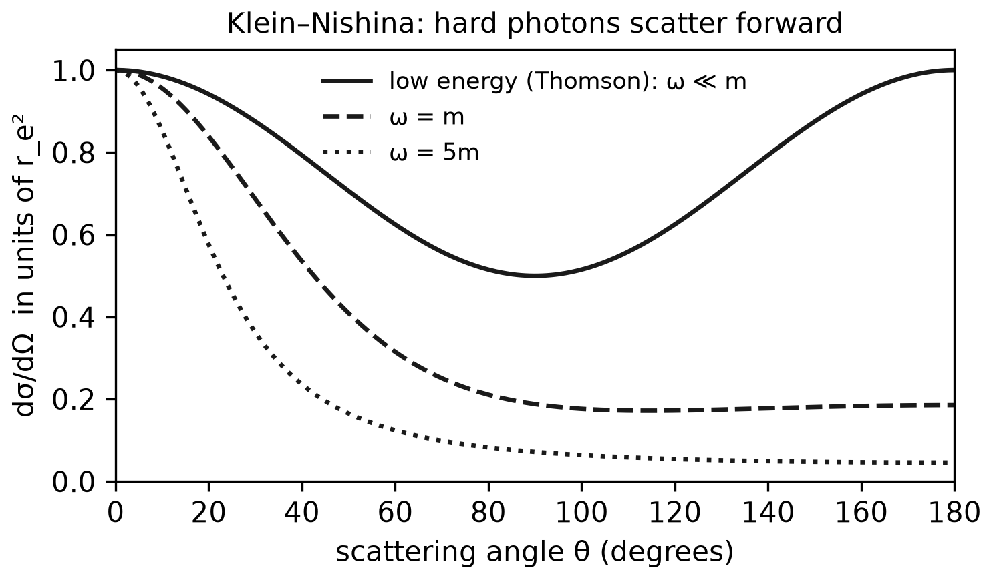
Figure 57.2. The Klein–Nishina angular distribution for several photon energies: forward scattering dominates as the energy rises; at low energy it reduces to Thomson's 1 + cos²θ.

5 Connections to QED
Result of this lesson | Where it is used next
T_{AA}=T_{BB}=−8su, T_{AB}=0 (massless) | Completes the calculation Lesson 50 set up
(1/4)Σ|ℳ|²=−2e⁴(s/u+u/s) | One of the most quoted results in introductory QED, now fully derived
q_{A}·q_{B}=0 | The same zero that removes Lesson 56's interference term, now recurring in a second, independent calculation
No relative sign between diagrams | Confirms the general rule of Lesson 56, Worked example 1: sign follows the statistics of the exchanged role, not the diagram count
Positivity from s>0, u<0 | A general consistency check, as in Lesson 56, Worked example 5
Lesson 58 turns to pair production, γγ→e⁻e⁺, obtained from this process by reading time backward, and checks how much of this lesson's structure survives that reversal.

6 Summary
- Compton scattering's two diagrams, set up in Lesson 50, combine with a plus sign, since the exchanged role (which photon field pairs with which external photon) is bosonic.
- Spin-averaging and summing, using electron completeness and the covariant photon polarization sum, reduces the calculation to three traces, T_{AA}, T_{BB}, T_{AB}.
- T_{AA}=T_{BB}=−8su in the massless limit, derived by the same method as Lesson 56.
- T_{AB}=0 identically, because the interference trace's middle contraction is proportional to q_{A}·q_{B}, which vanishes in the massless limit as it did in Lesson 56.
- The complete result is (1/4)Σ|ℳ|²=−2e⁴(s/u+u/s), compact, symmetric under s↔u, and manifestly positive.

Exercises
No | Problem
1 | Core. Restate Lesson 50's two Compton diagrams and their internal momenta, and explain why they combine with a plus, not a minus, sign.
2 | Core. Write out T_{AA}, T_{BB}, T_{AB} with explicit index placement, following Section 1.2, and identify which pair of indices is "adjacent" and which is "interleaved" in each.
3 | Core. Verify the spin-and-polarization averaging factor is 1/4, citing the two unmeasured initial degrees of freedom.
4 | Extension. Derive γ^{α}(p̸+m)γ_{α}=−2p̸+4m, following Lesson 56, Exercise 7.
5 | Core. Expand (q̸_{A}+m)γ^{α}(p̸+m)γ_{α}(q̸_{A}+m), apply Section 2.1, and reduce to the massless leading term 32(q_{A}·p)(q_{A}·p′)−16q_{A}²(p·p′), following the method of Lesson 56, Exercise 8.
6 | Extension. Derive q_{A}·p=s/2, q_{A}·p′=s/2, and p·p′=−t/2, using s=(p+k)²=(p′+k′)², t=(p−p′)², and momentum conservation p+k=p′+k′, all in the massless limit.
7 | Core. Substitute Exercise 6's values into Section 2.2's formula and derive T_{AA}=−8su, showing every step.
8 | Core. Using Worked example 2's relabeling, derive T_{BB}=−8su without repeating Exercise 5's expansion from scratch.
9 | Extension. Derive k·k′=−t/2 from (k−k′)²=(p′−p)²=t, using k²=k′²=0.
10 | Extension. Derive p·k′=−u/2 from u=(p−k′)², using p²=k′²=0.
11 | Core. Substitute the results of Exercises 9–10 (plus k·p=s/2) into Section 3.3's expression for q_{A}·q_{B} and verify it equals zero.
12 | Extension. Carry out Section 3.1's reversal identity explicitly for the chain [p̸γ_{β}q̸_{B}], confirming γ^{α}[p̸γ_{β}q̸_{B}]γ_{α}=−2q̸_{B}γ_{β}p̸.
13 | Core. Using the two-object identity γ^{μ}γªγ^{b}γ_{μ}=4gªb, verify γ^{β}q̸_{A}q̸_{B}γ_{β}=4(q_{A}·q_{B})I, and combine with Exercise 11 to confirm T_{AB}=0.
14 | Extension. Assemble Section 4's final formula from T_{AA}, T_{BB}, T_{AB}, and the propagator denominators, verifying every numerical factor.
15 | Extension. Explain why (1/4)Σ|ℳ|² must be positive for physical Compton scattering, and verify Section 4's formula respects this using s>0, u<0.
16 | Challenge. Using Lesson 56's crossing-symmetry preview (Exercise 16 there), state which of electron-positron annihilation's Mandelstam variables (s′, t′, u′) correspond to this lesson's s and u, and use that correspondence to obtain this lesson's result from Lesson 56's 2e⁴(t′/u′+u′/t′), including the overall sign.

Solutions
Attempt each exercise before reading its solution. If you are stuck, read only the first sentence of the solution, then try again.
1. The direct diagram has internal momentum q_{A}=p+k (q_{A}²=s); the crossed diagram has internal momentum q_{B}=p−k′ (q_{B}²=u) (Lesson 50, Sections 2.3 and 3.1). They combine with a plus sign because the two diagrams differ only in which of the two photon field insertions is paired with the incoming versus outgoing photon, a bosonic reassignment carrying no minus sign (Lesson 48, Section 2.1; Lesson 56, Section 1.2).
2. T_{AA}=Tr[(p̸′+m)γ^{β}(q̸_{A}+m)γ^{α}(p̸+m)γ_{α}(q̸_{A}+m)γ_{β}]: α is adjacent, directly surrounding (p̸+m); β surrounds the pair (q̸_{A}+m)...(q̸_{A}+m) with everything in between. T_{AB}=Tr[(p̸′+m)γ^{β}(q̸_{A}+m)γ^{α}(p̸+m)γ_{β}(q̸_{B}+m)γ_{α}]: α now surrounds the longer chain (p̸+m)γ_{β}(q̸_{B}+m), interleaved with the β contraction rather than nested inside it.
3. Two initial degrees of freedom are unmeasured and unprepared: the incoming electron's spin and the incoming photon's polarization; Lesson 52, Section 1.2, assigns a factor of 1/2 per unmeasured initial spin or polarization, giving (1/2)(1/2)=1/4 overall.
4. Identical to Lesson 56, Exercise 7: γ^{α}(p̸+m)γ_{α}=γ^{α}p̸γ_{α}+mγ^{α}γ_{α}=−2p̸+4m, using γ^{μ}γªγ_{μ}=−2γª and γ^{μ}γ_{μ}=4.
5. Following Lesson 56, Exercise 8's method exactly (with p₁→p, p₂→p′, and q_{A} unchanged), the leading (mass-independent) term of the expansion, after sandwiching by γ^{β}⋯γ_{β} and tracing against (p̸′+m), is 32(q_{A}·p)(q_{A}·p′)−16q_{A}²(p·p′), with every mass-dependent term vanishing as m→0.
6. From s=(p+k)²=p²+2p·k+k²=2p·k (massless), p·k=s/2, so q_{A}·p=(p+k)·p=p²+k·p=s/2. From s=(p′+k′)² similarly, p′·k′=s/2. Using momentum conservation k=p′+k′−p, k·p′=(p′+k′−p)·p′=p′²+k′·p′−p·p′=s/2−p·p′; and from t=(p−p′)²=−2p·p′ (massless), p·p′=−t/2, so k·p′=s/2+t/2. Then q_{A}·p′=(p+k)·p′=p·p′+k·p′=−t/2+(s/2+t/2)=s/2.
7. T_{AA}=32(s/2)(s/2)−16s(−t/2)=32(s²/4)+8st=8s²+8st=8s(s+t). Using s+t+u=0, s+t=−u, so T_{AA}=8s(−u)=−8su.
8. By the s↔u relabeling of Worked example 2 (since q_{B}²=u takes over the role q_{A}²=s played), T_{AA}'s formula 8s(s+t) becomes 8u(u+t); using s+t+u=0, u+t=−s, giving T_{BB}=8u(−s)=−8us=−8su.
9. (k−k′)²=k²−2k·k′+k′²=−2k·k′ (both massless); using momentum conservation k−k′=p′−p, so (k−k′)²=(p′−p)²=(p−p′)²=t, giving −2k·k′=t, so k·k′=−t/2.
10. u=(p−k′)²=p²−2p·k′+k′²=−2p·k′ (both massless), so p·k′=−u/2.
11. q_{A}·q_{B}=(p+k)·(p−k′)=p²−p·k′+k·p−k·k′=0−(−u/2)+s/2−(−t/2)=u/2+s/2+t/2=(s+t+u)/2=0.
12. Applying the three-object reversal γ^{μ}ABCγ_{μ}=−2CBA (Lesson 55, Section 3.1) with A=p̸, B=γ_{β}, C=q̸_{B} (as fixed matrices, with the μ-contraction here relabeled α): γ^{α} p̸γ_{β}q̸_{B} γ_{α}=−2q̸_{B}γ_{β}p̸, exactly reversing the order of the three factors.
13. γ^{β}q̸_{A}q̸_{B}γ_{β}=p_{A,a}p_{B,b}γ^{β}γªγ^{b}γ_{β}=p_{A,a}p_{B,b}(4gªb)=4(q_{A}·q_{B})I, using the two-object identity of Lesson 21 contracted with the momentum components of q_{A} and q_{B}. Substituting q_{A}·q_{B}=0 (Exercise 11) gives γ^{β}q̸_{A}q̸_{B}γ_{β}=0, so T_{AB}=−2Tr[p̸′·0·p̸]=0.
14. (1/4)Σ|ℳ|²=(e⁴/4)[T_{AA}/s²+T_{BB}/u²+2T_{AB}/(su)]=(e⁴/4)[−8su/s²−8su/u²+0]=(e⁴/4)[−8u/s−8s/u]=−2e⁴(u/s+s/u)=−2e⁴(s/u+u/s).
15. As a spin-and-polarization-averaged sum of |ℳ|² over specific configurations, the quantity is a sum of non-negative numbers and so must itself be non-negative (and, barring an exactly-vanishing amplitude at every configuration, strictly positive). For physical scattering, s=(p+k)²>0 (a timelike total four-momentum) and u=(p−k′)²<0 (spacelike, Lesson 53, Section 3.2, extended to this process), so s/u<0, making −(s/u+u/s) a sum of two positive numbers (since u/s is also negative, so −u/s is positive), confirming positivity directly.
16. Crossing the incoming positron of annihilation to an outgoing electron (p₂→−p′) and the photon k₁ to an incoming photon (k₁→−k) maps t′=(p₁−k₁)² to (p+k)²=s, u′=(p₁−k₂)² to (p−k′)²=u, and s′=(p₁+p₂)² to (p−p′)²=t. Lesson 56's 2e⁴(t′/u′+u′/t′) becomes 2e⁴(s/u+u/s), and moving one fermion between the initial and final states multiplies the spin-summed square by −1, giving −2e⁴(s/u+u/s), this lesson's result. Neither process has an interference term: in both, T_{AB} is proportional to q_{A}·q_{B}, which vanishes in the massless limit.

Mastery check
Before moving on, do the Core exercises without looking at the solutions and state this lesson's main result from memory. If both go smoothly, continue; if not, reread the sections the missed exercises cite.

Next lesson
Lesson 58 turns to pair production, γγ→e⁻e⁺, the process obtained from this lesson's by reading every diagram backward in time, and asks how much of Compton scattering's result carries over unchanged.

